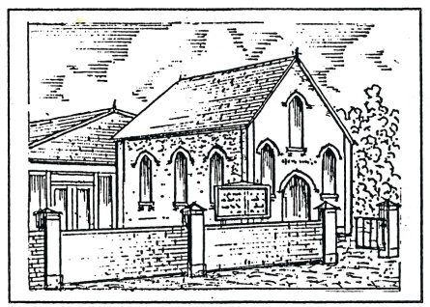
Albert Remmett
Trinity Methodist
Church, Broad Oak

A brief history

The Chapel

A Methodist congregation was established in Broad Oak during John Wesley's lifetime (1703-1791). There is no direct evidence that he came to Broad Oak, though he is known to have visited Robertsbridge, Northiam and Rye.¹ A group of supporters was established in Northiam in 1788 and amongst them was Stephen Blake, a cooper, who became the leader of the first group of Methodists in Broad Oak and Brede. They met at first in a cottage near Brede Green and afterwards at one in Broad Oak.² There were 15 names on the first membership return in 1811.

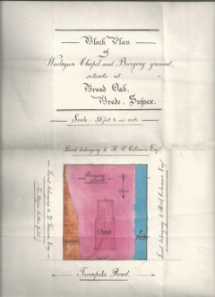
Services continued without incident until a day in 1814 when George York started preaching near the parish church as the congregation came out. Many people objected, throwing stones at the preacher and ringing the church and hand bells. William Coleman, whose family had farmed at Chitcombe for many generations, was amongst those who felt that the Methodists merited better support and accommodation, so he invited visiting Wesleyan ministers to stay at his home and built a room for worship near the main road at Chitcombe. When his father, a churchwarden for 23 years, did not allow it to be used for preaching, the room was converted to a cottage.
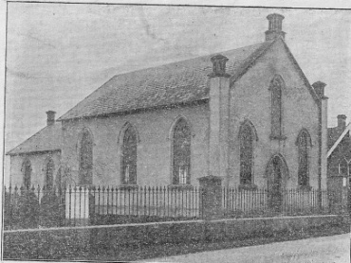
Not to be thwarted, William Coleman was the chief promoter of the first Wesleyan Chapel in Broad Oak, built alongside the turnpike road from Rye to Robertsbridge. Many people contributed and a chapel 33¹/₂ feet long by 23¹/₂ feet wide opened on June 28th, 1833. But it proved to be too small and, in 1855, two of William's sons, Horace and Carlos

erected the present building.² It was opened on September 6th by Rev George Brown Macdonald, grandfather of two famous men, Rudyard Kipling and Stanley Baldwin. The chapel seats about 80 people and the hall 40.

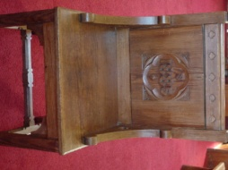
The oldest items in the interior would appear to be a minister's chair and a clock, both dated 1885. In 1901, the interior was refurbished with new pews, a new lobby and stained glass in the windows. One original pew remains in the gallery. A photograph taken on 8 August 1901 is held by the East Sussex County Archive.³
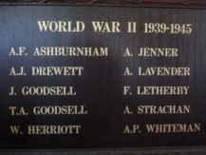
There are war memorials to 25 local men from the First World War and 10 from the second. The latter was not added until 1989, when it was financed by the British Legion.

Each generation has made additions and alterations to the building to meet its needs. In 1929, the hall was divided into a classroom and other facilities added. A letter from Carlos Crisford to Edmund Austen on 24 June reads: "The classroom is not very large but would seat 20 persons easily. I have also provided lavatory accommodation notwithstanding there is no drainage system or water supply. A chemical closet could be provided and the waste from the lavatory basin could be discharged into a pail removed by the Chapel Keeper. For heating the rooms, I should install electricity with an electric plug in the walls where shown. One electric stove would serve both rooms and that not very often." Electric lighting was installed at that time.

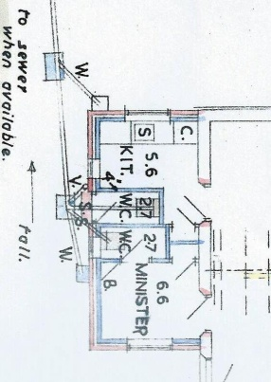
The church was separated from the hall only by a curtain until 1954 when a partition wall was installed. The builders, John Perigoe & Son of Northiam, also made the cross. In 1961, the partitions were removed from the hall and an extension added to the east side to provide a small kitchen and an external door (now a door into the kitchen) from which the congregation could reach an outside door to a w.c. Its position can still be seen from the change in floor level in the room now used as a servery and store. There was no such hardship for the minister, who had a new vestry with a private w.c. to one side (now a cleaning store and a cupboard). The gallery was shut off and false ceilings fitted in 1964.

The present layout dates from 1974, when a further extension was built by George Griffin to provide a larger kitchen, a rear vestibule and indoor toilets.
Regrettably this covered the position of nine graves and the loosened soil is thought to have contributed to some subsequent subsidence. The extension was underpinned in 1994, the front wall rebuilt in 1996 and electric heating installed in the 1998. In the following year, the worn floorboards in the hall were replaced with chipboard and a brick toilet block towards the back-left of the graveyard, much used by the local lads, was demolished.
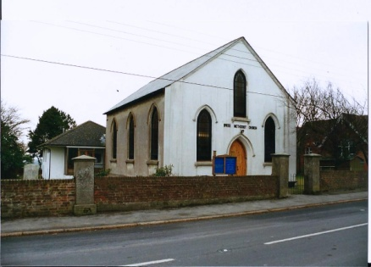
The building was listed as Grade 2 in 1987.⁴ The description reads "Three windows. Stuccoed. Slate roof. Pointed windows. Gable to north front with one window over the doorway and one on each side of it."

The Crypts and Graveyard

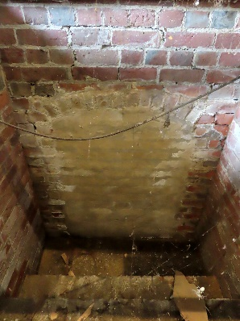
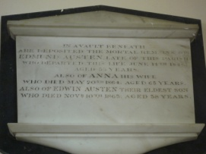
In 1842, the Rector of Brede refused to read the burial service for Carlos's brother John on the grounds that he had not been baptised, so the service was read by another brother Ephraim, standing outside the church yard fence. On their return from the funeral, the Coleman's younger daughter, Caroline, who was dying from consumption, asked her father to build a vault in the Broad Oak chapel so that there would be no unpleasantness over her burial. She died in less than a month and was laid to rest in the ground behind the church and shortly afterwards in a vault below the chapel, later used also for other members of the Coleman family (his wife Hannah d1843 and William d1852). A second vault was later constructed for the Austen family (Edmund d1846, his wife Anna, who was Carlos Coleman's sister, d1864 and their eldest son Edwin d1865).

Two sets of eight fairly modern concrete steps, leading to a depth of about 1.85m were rediscovered when the hall floor was replaced in 2023. The crypts have been bricked up, but the entrances can be clearly seen. Each is about 1m wide, with an arched roof about 1.4m high at the apex. The crypts themselves are under the chapel, but too deep to be seen under the chapel floor, and so the steps must have originally been outside the rear wall.

The oldest grave, towards the western boundary, is for other members of the Coleman family (Ephraim d1865, Emilie d1869, Emily d1870 and Sophronia d1878).

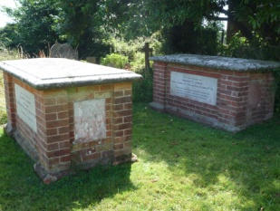
Horace Coleman died on 3 October 1888, although an Anglican throughout his life, in his dying moments he asked to be interred in the Wesleyan Burial Ground at Broad Oak. Carlos died on August 21 1896; the inscription on his tomb is very apt: "He being dead yet speaketh". The Coleman brother's tombs are conspicuous in the graveyard to this day.

Two additional pieces of land were given in the early years and by 1946, 500 people had been buried there. A plan drawn up from original records in 1989 shows 555 named plots.
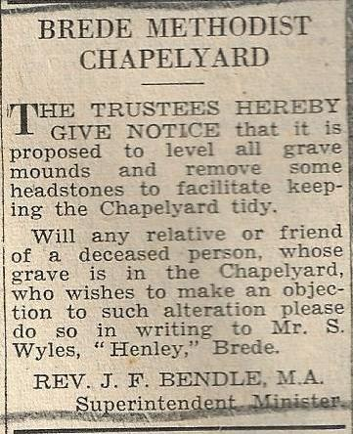
But on 29 August 1959, a notice in the Hastings and St Leonard's Observer warned people that unless a relative or friend of a deceased person objected, all grave mounds would be levelled and headstones removed to facilitate keeping the church yard tidy. Those who objected were told that they must pay for future upkeep.

Regrettably only about 40 of the pre-1950s graves are visible today, though some of the early gravestones survive, having been used to provide slabs for a path. The graveyard is still in use, mostly for interment of ashes. Details of the 634 burials, including interment of ashes, may be found on Trinity’s website www.trinitybroadoak.org.uk. There are two war graves.

Sunday School and Youth Groups

A Sunday School was established in 1833 and, by 1854, there were 180 pupils. A school room was built at the back of the chapel but was pulled down when the new chapel was built the following year.

In 1871, Horace and Carlos Coleman built Broad Oak Day School (now Broad Oak Community Primary School), next to the chapel. It was opened on January 16th, 1872 and leased to the parish free of charge, provided that it was open for religious teaching on Sunday. Later, to keep the school free from sectarian influences, the brothers enlarged some premises that they
had built for Broad Oak Benefit Society and in 1885 opened it for use as a Sunday School.

In 1920, average attendance had reduced to 65 and numbers continued to decline, with normally about 30 in the 1930s and 1940s. In 1933 children started to attend chapel until the children's hymn. But there must still have been more than one meeting each Sunday as in 1935 Stanley Pelling and Eric Standing received Bibles for attending on all 106 possible occasions. Stanley also received a seven-year bar to his medal, having attended every Sunday in that period.

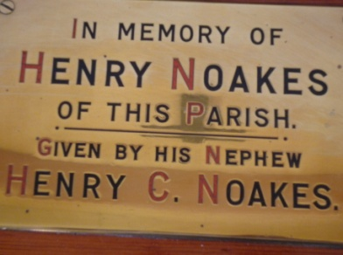
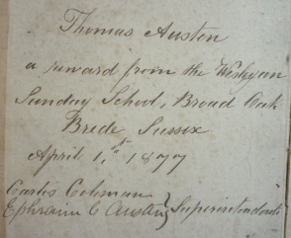
It had long been the custom to present Bibles to the pupils and one of the early Bibles, presented to Thomas Austen by Carlos Coleman and Ephraim Austen in 1877 survives in the chapel. In 1924, Henry Noakes left £1,000 in trust and instructed that the chapels at Brede and Peasemarsh should be given £2.10/- to buy Bibles for the pupils on each Anniversary Sunday. As the custom continued for many years, the collection of Bibles held by some pupils must have been substantial!

A piano, purchased in 1926 for £42, raised by public subscription and proceeds of entertainments, was handed over to the Trustees of Broad Oak Sunday School provided they keep it in good condition and allow Brede Orchestra to have free use of it as required. It was replaced in 2022 by a more modern instrument.

The separate Sunday School building was sold to a Mr Wyles in 1961⁵ for a price of £1850 and is now two semi-detached houses, three buildings beyond the school. The estate agent's particulars noted "main hall a fine room of about 56 ft length (including platform 10 ft) x about 20 ft width fitted brick fireplace with marble surround. Secondary Hall about 21 ft 9 insx15 ft 9 ins fitted with brick fireplace with marble surround." Thereafter, pupils used the chapel hall.

Though the numbers attending the Sunday School diminished over the years, other groups were established during the week, including some run by the community.
For instance, in 1953 the fortnightly Young People's Fellowships were merged into a Junior Guild to meet weekly. Youth Clubs for 11-16 year olds and 16+ were established in 1973. Church Council Minutes in 1978 mention play groups on Monday and Friday mornings, a Seekers group on Wednesday evening and a Toddler's Club on Thursday morning. In 1981, a weekly coffee bar was started for teenagers.

People and Community

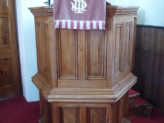
The important role of William Coleman and two of his sons Horace and Carlos has already been mentioned. Carlos was deeply involved with the chapel throughout his life, being an active preacher and superintendent of the Sunday School until his death.

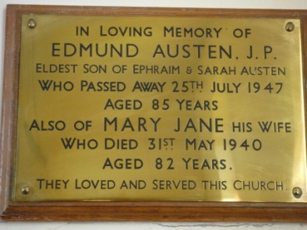
But the contribution of generations of other families should not be underestimated. Amongst these, the Austen family were probably the most prominent. Ephraim and Sarah Austen were members of the founding group and their son Edmund and daughter Orlow Austen were leaders for many years. Many others have given faithful service over the generations, including the Beaney, Bryant, Crouch, Goodsell and Hook families.

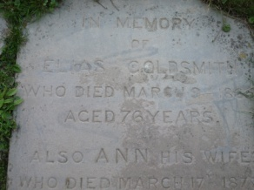
Some of the surviving gravestones give an interesting snapshot of the congregation and local life in the 19th century. For instance, Kelly's Post Office Directory for 1867⁶ tells us that John Fuggle (d.1881), whose gravestone is in the path to the right of the main door, was the grocer and draper in Broad Oak, whilst Peter Hook (d.1869) was the local butcher. His headstone is in the path to the east of the chapel with that of Elias Goldsmith (d.1865), a farm bailiff.

As for many years the chapel provided the only hall in Broad Oak, it has been used by many community organisations. The WI, various music and flower groups and children's football training are all mentioned in Council Minutes or the accounts. The hall was also used by health services. Polio vaccinations were given in 1962/63, a Child Health Clinic was established in 1975 and a Chiropody Clinic, established in 1976, ran for many years.

Recent Times

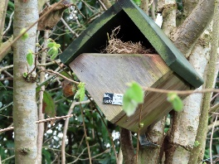
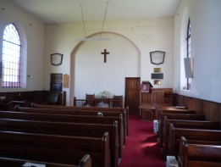
In common with most churches in the UK, the congregations at Broad Oak and neighbouring villages declined in the second half of the 20th century. Those at Broad Oak, Beckley and Westfield started worshiping together at different locations and adopted the joint name of 'Trinity'. The three congregations formally joined under one Church Council on 1 September 2004. Westfield Chapel was closed in 2004. Beckley sought permission to close in 2007; the premises were sold in 2009. The Mission Statement agreed in 2004 is shown at the end of these notes. In 2017-18, the churchyard was developed into a wildlife garden for the community and an outdoor classroom for the primary school.

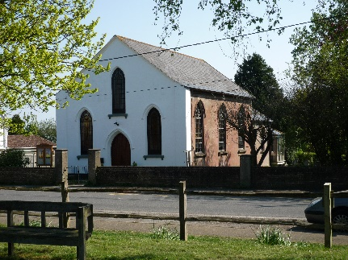
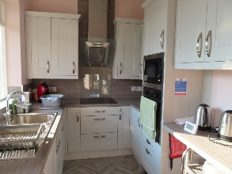
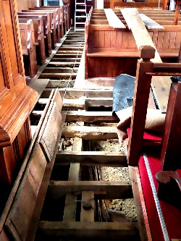
Our building has been substantially renovated and updated in recent years. The roof was first repaired with the assistance of the Listed Places of Worship Roof Repair Fund. The side entrance and two cantilevered extensions to the rear were all rebuilt. An accessible toilet and a new kitchen were fitted. Heating and lighting were renewed throughout the building. Glass was fitted between the front vestibule and the body on the chapel, allowing visitors to see in and worshipers to feel more connected with the community. An infestation of deathwatch beetle was treated, then a new carpet laid in the chapel and a laminate floor in the hall. The front, rear and interior were redecorated. Every effort has been made to repair and modernise the chapel without destroying its essentially Victorian character.

References
Information on the early life of the church is taken from the first two references, without citation of individual points.
1. Austen E, 1946. Brede the Story of a Sussex Parish. Adams & Sons, Rye, Sussex
2. Austen E, 1867. Memorial Sketch of Carlos Coleman. J L Deacon, The Library, Rye
3. East Sussex Record Office NNB 74/2/1
4. http://www.britishlistedbuildings.co.uk/en-292369-brede-methodist-church-brede-east-sussex
5. East Sussex Record Office Archive ACC8464
6. Kelly's Post Office Directory of Essex, Herts, Middlesex, Kent, Surrey and Sussex, 1867

Early papers are kept in the East Sussex County Archive.

Version 6 January 2024. Updates and corrections and should be sent to stephenj.hampson@btinternet.com

Mission Statement from 13th March 2004

- To act as a united Society to promote a Methodist witness in the villages we already serve. To pool our resources and manpower. To care for one another. (Acts 2 vv44-47, Mark 1 v38)

- To provide regular worship which is varied, evangelical and liturgical. To seek quality in worship. (1 Cor 14 v40)

- To spread God's love in the area we serve. To offer warm fellowship and pastoral care. To serve people at important times of their lives, from baptism, through marriage, the death and committal.
(1 John 4 v21)

- To open our premises and fellowship to the community around us. (Gen. 18 v3)

- To promote Bible study, house-groups and mid-week sacraments in each of our villages. (Acts 2 v42)

- To maintain activities, devotional and social, in which we are already involved, to encourage new ventures, and to be responsible in our charitable giving. (1 Cor. 12 vv4-6)

- To be a supportive and participating Society within our Circuit. (Eph. 3 v4)

- To pursue ecumenical links, particularly with our Anglican neighbours, in accordance with the principles of the Anglican/Methodist Covenant. (John 17 vv20-21)

- To be a Jesus based church, acting according to biblical principles. (Phil. 2 v5)

